25.027 |  | Trampoline Round d=1480 (Braided ribbon)
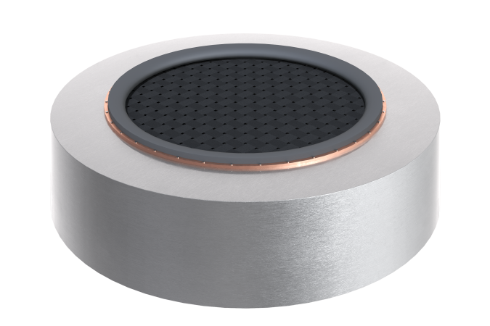

Size, mm: | 2020x2020x400 | Weight, kg: | 165
Material characteristics
Materials: metal, rubber.
Package includes: trampoline - 1 pc.
The built-in round trampoline is supplied as a single element, ready for installation, and includes a welded frame made of galvanized steel sheets 3–4 mm thick, a web of polyester belts, the belts can withstand 4.5 tons of breaking force.
Element coating:
- metal – hot zinc

