25.023 |  | Trampoline Round d=1250 with light (rubber)
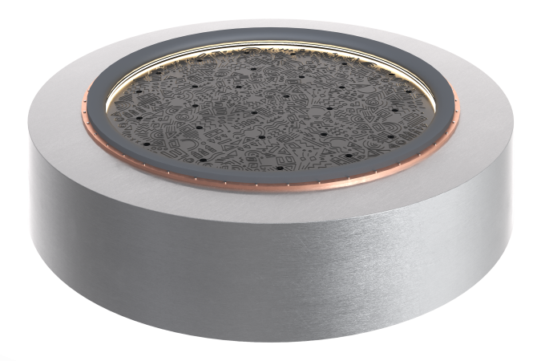

Size, mm: | 1820x1820x400 | Weight, kg: | 210
Material characteristics
Materials: metal, rubber.
Package includes: trampoline - 1 pc.
The built-in round trampoline with lighting is supplied as a single element, ready for installation, and includes a welded frame made of galvanized steel sheets 3-4 mm thick, a reinforced rubber sheet with a tread 7-8 mm thick and galvanized springs 140 mm long with a load of up to 55 kg. The springs are attached through anti-friction bronze bushings, eliminating wear and creaking, which are subject to replacement every 3 years.
Element coating:
- metal - hot zinc

