ML6608 |  | Square bin
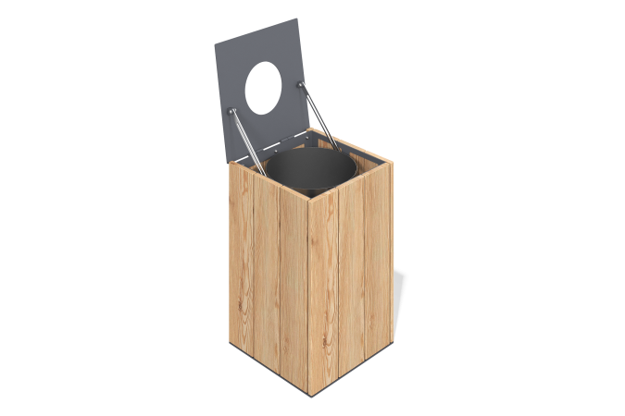

Size, mm: | 450x460x700 | Weight, kg: | 1.3198
Material characteristics
Materials: softwood timber, metal
Package includes: urn - 1 pc., fastener kit - 1 pc., lid - 1 pc.
The urn is made of a durable welded metal frame to which wooden bars are fixed. The bars are made of planed pine boards 20 x 140 x 6000 mm. Special wood treatment allows for all-season use of the urn outdoors. The urn is equipped with a removable galvanized container.
The equipment uses stainless steel fasteners. The protruding parts of the threaded connections and the open parts of the pipes are covered with plastic plugs.
Coating of the elements:
- metal - powder zinc primer, powder paint;
- timber - glazing primer, water-dispersion varnish.

