ML6527 |  | Table with benches
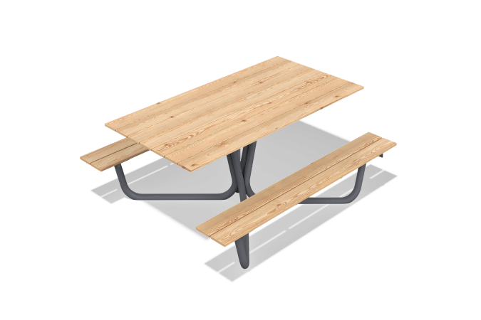

Size, mm: | 1680x2000x770 | Weight, kg: | 118.1863
Material characteristics
Materials: coniferous wood, metal

