ML3609 |  | Football gates
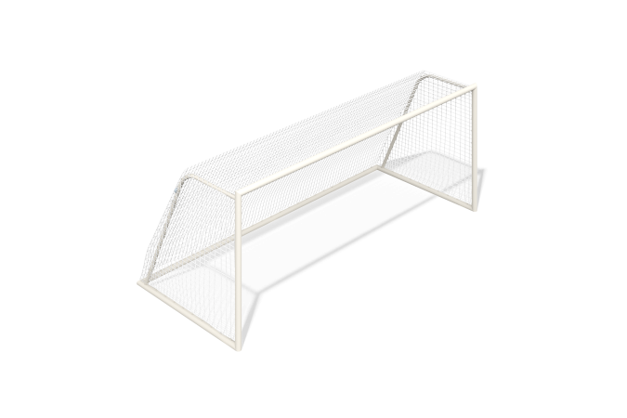

Size, mm: | 2285x5351x2096 | Weight, kg: | 182.900649
Material characteristics
Materials: metal, polypropylene.
Contents: Gate - 1 pc., Net - 1 pc., Fastening kit - 1 pc.
The football goal is made of a round metal pipe. The gate is made of steel pipe with a diameter of 89 mm and a wall thickness of 3 mm. The net on the gate is made of polypropylene.
The equipment uses stainless steel fasteners. The protruding parts of threaded connections and open parts of pipes are closed with plastic plugs.
Element coverage:
- metal - powder zinc primer, powder paint.

