39.091 |  | Bin HPL
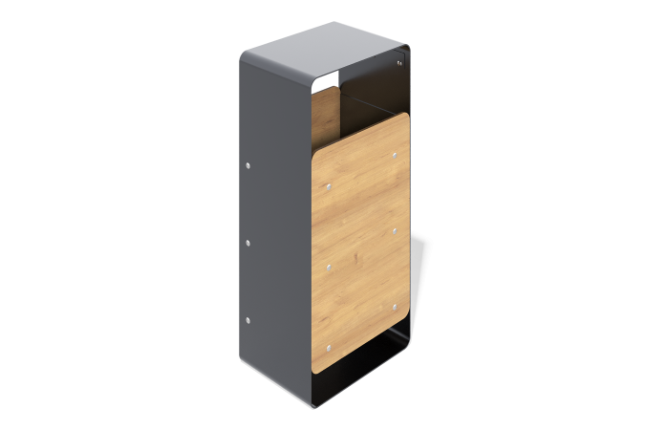

Size, mm: | 310x440x950 | Weight, kg: | 0
Material characteristics
Materials:
metal, plastic
Package includes:
Urn – 1 pc.
The urn frame is made of galvanized sheet metal 4 mm thick with a powder coating that is resistant to corrosion and mechanical damage. The lining is made of HPL plastic 12 mm thick with a UF coating that protects against ultraviolet radiation and atmospheric influences.

