ML4001 |  | Play System
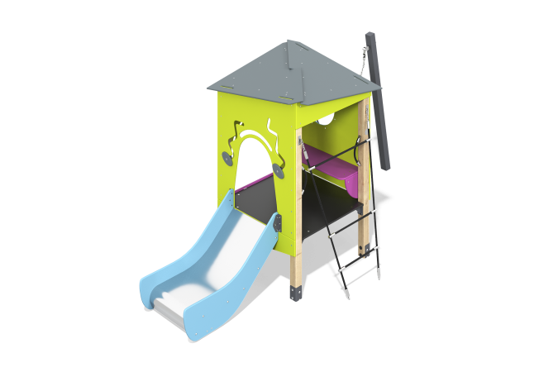

Size, mm: | 1456x3587x2540 | Weight, kg: | 168.513912
Material characteristics
Materials: softwood timber - pine, metal, stainless steel, moisture-resistant birch plywood; laminated plywood with anti-slip coating; monolithic polycarbonate; rope, stainless fasteners.
Contents: embedded parts - 1 set, support posts - 4 pcs., roof - 1 set, floors - 1 set, fencing and decorative panels - 1 set, rope access - 1 pc., lifting panel - 1 pc., slide - 1 pc., swing - 1 set, fastening set - 1 set.
The equipment consists of 1 house and a swing. The support posts are made of laminated pine timber 100x100 mm, profile B. The floor of the houses and the steps of the stairs are made of laminated plywood 21 mm thick with an anti-slip coating.
Decorative panels, frame and playing elements are made of moisture-resistant birch plywood with a thickness of 15 mm and 18 mm. Drawings are applied to panels and game elements using engraving and UV printing. Decorative inserts on the panels in the form of windows are made of monolithic polycarbonate 6 mm thick.
The complex contains:
- rope manhole made of six-strand reinforced polypropylene rope d=16 mm.
-swing with rubber suspension.
The play complex includes 1 straight slide.
A straight slide h=0.6 m, consists of a slope and sides, in turn made of stainless steel sheet 1.5 mm thick and moisture-resistant plywood 15 mm thick.
The equipment uses stainless steel fasteners. Protruding parts of threaded connections and open parts of pipes are closed with plastic plugs.
Element coverage:
- metal - powder zinc primer, powder paint;
- timber - glaze primer, water-dispersion varnish.
- plywood - acrylic primer, acrylic enamel, water-dispersion varnish.

