ML0508 |  | Double swing
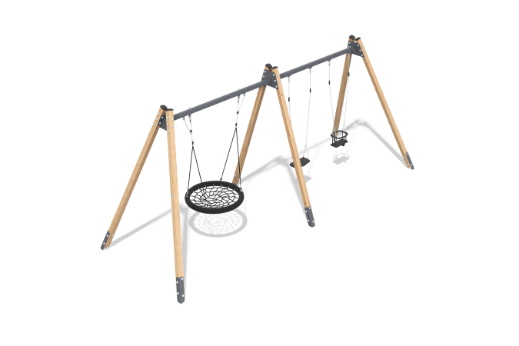

Size, mm: | 2235x5392x2719 | Weight, kg: | 228.9968
Material characteristics
Materials: Coniferous wood - pine, metal, rubber.
Package contents: Wooden racks – 6 pcs, Crossbar – 2 pcs, suspensions - 3 pcs, a set of fasteners - 1 pc.
The swing frame consists of 6 timber posts and 2 metal crossbars fixed between them. The support posts are made of glued pine timber with a cross section of 100x100 mm. The profile is square, the radius of the rounded corners is R10. The crossbars are made of a metal profile tube with a cross section of 80x60 mm and a thickness of 3 mm. Suspensions are attached to the frame: a "Nest" suspension, a "Rubber" suspension and a "Cradle" suspension. The Cradle suspension consists of an anti-slip seat, vertical restraints and a rim. The seat is reinforced with an aluminum plate. The rim is ruptured — there is no protective edge in front. All parts are made of metal and covered with thermoplastic. The rim of the "nest" suspension is made of metal pipe, the weaving inside the ring is made of reinforced four-row rope with a diameter of 16 mm. Polyester, which is part of the braided rope, is UV-resistant. Each strand is reinforced with metal wires.
The suspension is attached to the swing by stainless steel slings. The slings are attached to the support crossbar by means of a bearing assembly with a rolling mechanism, through a chain made of stainless steel.
Stainless steel fasteners are used in the kit.
Coating of the elements:
- metal - powder zinc grunt, powder paint;
- timber - lessening primer, water-dispersion varnish.

