ML0107 |  | Seesaw Horses
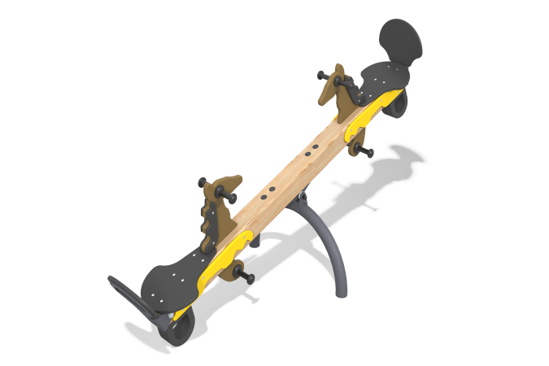

Size, mm: | 655x2060x810 | Weight, kg: | 33.9
Material characteristics
Materials: softwood timber - pine, plywood, metal, stainless fasteners.
Package contents: frame - 1 pc., base - 1 pc., seats - 2 pcs., backrest - 2 pcs., decorative panels - 2 pcs., backrest support - 2 pcs., mounting kit – 1 pc.
The seats and backs are made of plywood FSF 15 mm, the edges and corners are rounded.
The decorative element is made of FSF plywood with a thickness of 24 mm.
The swing frame is a 100x100 mm glued pine timber. The seat fastenings to the frame are implemented using supports made of metal sheet 6 mm thick. The handles and footrests are made of plastic.
The equipment uses stainless steel fasteners. The protruding parts of the threaded connections and the exposed parts of the pipes are covered with plastic plugs.
Coating of the elements:
- metal - powder zinc grunt, powder paint;
- timber - lessening primer, water-dispersion varnish;
- plywood is a liquid paint, water-dispersion varnish.

