43.021 |  | Inclined tunnel 800 mm
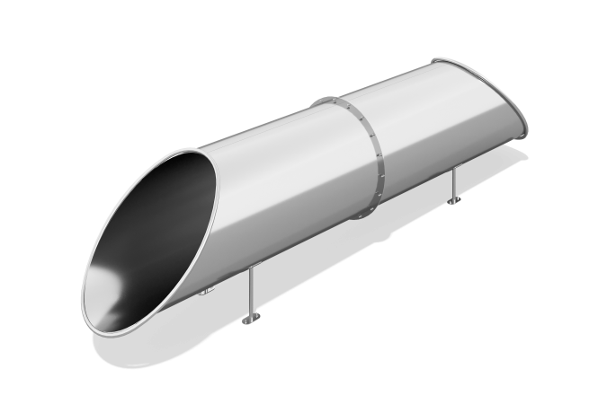

Size, mm: | 804x4326x1104 | Weight, kg: | 309.17108
Material characteristics
Materials: stainless steel.
The hill is not included in the equipment delivery and must be manufactured and installed by the customer independently or ordered separately.
The tunnel is made of stainless steel sheet 2 mm thick.
The support legs are attached with bolts through plates with four holes to embedded elements made of a metal round pipe.
Contents: tunnel – 1 pc.

