38.063 |  | Shade canopy with benches 5000x8000 (larch)
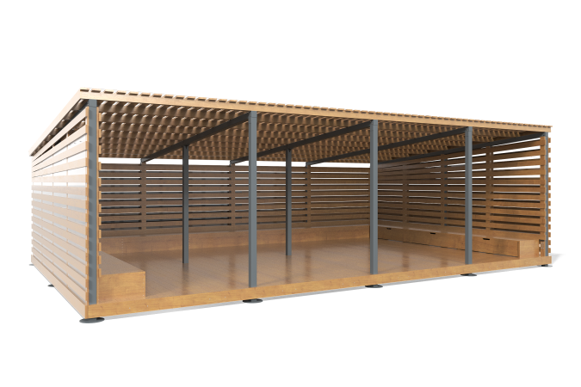

Size, mm: | 5000x8000x2500 | Weight, kg: | 0
Material characteristics
Materials: softwood timber - pine, planed boards - larch; metal, moisture-resistant birch plywood, monolithic polycarbonate, stainless fasteners.
Package contents: embedded parts -1 set, frame boards – 1 set, roof - 1 set, floor - 1 set, metal supports - 1 set, drawers - 6 pcs., a set of fasteners - 1 set.
The frame and cladding are made of planed larch boards 20x90x5000 mm, 45x90x6000, 28x140x4800 mm and 28x90x6000 mm, as well as pine bars 40x40 mm, 50x50 mm. The metal frame is presented in the form of racks, which are made of a profile tube 80x80x3 mm, crossbars 40x20x2 mm, 60x40x2 mm.
The canopy spacer is made of monolithic polycarbonate with a thickness of 5 mm. The bottom of the boxes is made of birch plywood 9 mm thick.
The equipment uses stainless steel fasteners. The protruding parts of the threaded connections and the exposed parts of the pipes are covered with plastic plugs.
Coating of the elements:
- metal - powder zinc grunt, powder paint;
- timber - lessening primer, water-dispersion varnish.

