23.037 |  | Play Panel Food Chain
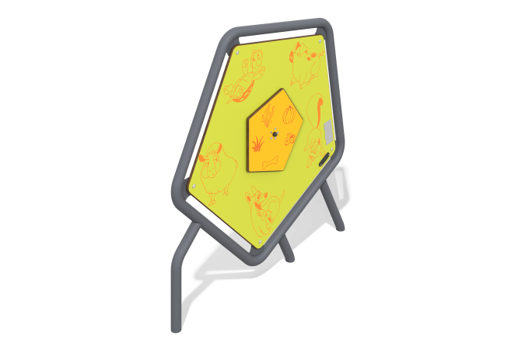

Size, mm: | 85x1179x1261 | Weight, kg: | 42.114
Material characteristics
Materials: metal, HPL plastic, stainless steel fasteners.
Contents: Panel frame – 1 pc., Game panel – 1 pc., fastening kit – 1 pc.
The developmental element is a metal frame in the shape of a pentagon on metal stands, inside of which a pentagonal panel is fixed. In the middle of the panel there is a “food chain” game element with a rotating element, on which corresponding drawings of animals and food are applied. The panel and rotating cover are made of HPL plastic 14 mm thick. The frame of the gaming panel is made of a metal round pipe with a diameter of 48 mm and a wall thickness of 3 mm.
Drawings are applied to panels and game elements using engraving and UV printing.
The complex uses stainless steel fasteners. Protruding parts of threaded connections and open parts of pipes are closed with plastic plugs.
Element coverage:
- metal - powder zinc primer, powder paint.

