35.020 |  | High wait table for dogs
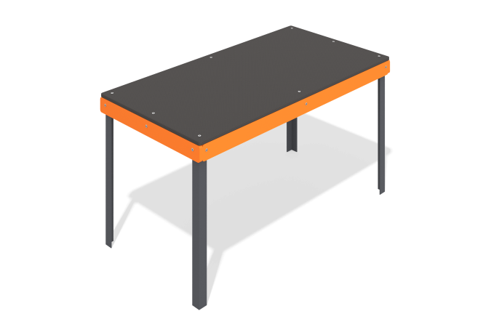

Size, mm: | 618x1218x650 | Weight, kg: | 15.092
Material characteristics
Materials: Metal, moisture-resistant birch plywood, moisture-resistant laminated birch plywood with anti-slip coating.
The high podium consists of corners measuring 40 mm x 40 mm x 4 mm with plywood elements 15 mm thick and laminated plywood 15 mm thick installed on them. All open parts of the pipes are closed with 40 mm x 40 mm plugs; the fasteners have no traumatic protrusions or edges.
Contents: Columns - 4 pcs., Floor - 1 pc., Plywood panels - 4 pcs., fastening kit - 1 pc.

