35.005 |  | Small dog walk ramp
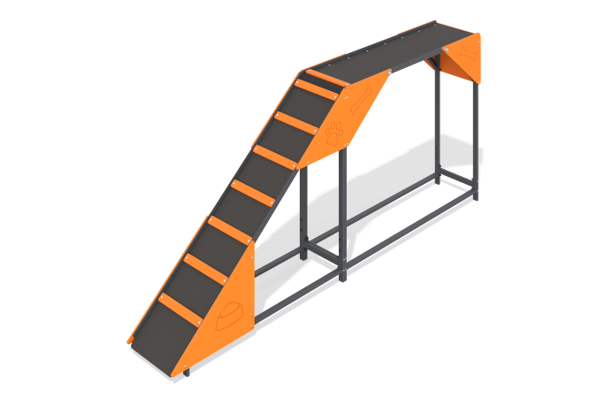

Size, mm: | 424x2951x1275 | Weight, kg: | 79.968
Material characteristics
Materials: Metal, moisture-resistant birch plywood, moisture-resistant laminated birch plywood with anti-slip coating.
The ladder element with a platform is a two-section equipment for dogs. The structure consists of a metal frame, 15 mm thick laminated plywood decking and 12 mm thick plywood decorative themed elements. The product is painted with polymer paints.
Contents: Frame - 1 piece, Steps - 7 pieces, Floor - 1 piece, Plywood panels - 6 pieces, fastening kit - 1 piece.

