35.018 |  | Dog crawl tunnel 3m
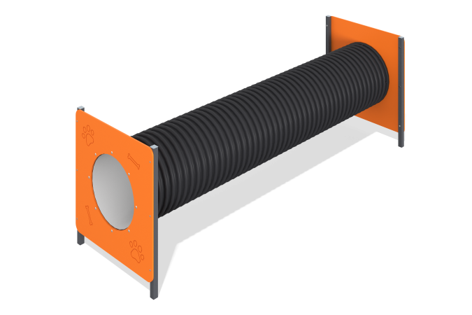

Size, mm: | 890x3015x1005 | Weight, kg: | 159.792
Material characteristics
Materials: Metal, moisture-resistant birch plywood, pipe.
A 3 m dog tunnel is a structure made of a pipe, 12 mm thick plywood, fixed on both sides of the pipe to square steel pipes 40 mm x 40 mm x 2 mm. The product is painted with polymer paints. All open parts of the pipes are closed with 40 mm x 40 mm plugs.
Contents: Stands - 4 pcs., plywood elements - 2 pcs., pipe - 1 pc., fastening kit - 1 pc.

