35.014 |  | Adjustable jump bar
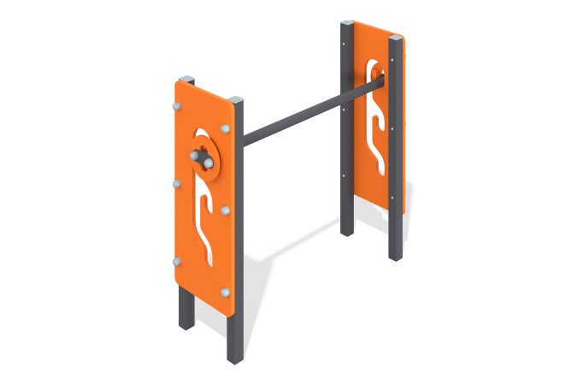

Size, mm: | 280x916x823 | Weight, kg: | 18.377
Material characteristics
Materials: Metal, moisture-resistant birch plywood.
The adjustable barrier consists of 4 racks made of pipe 40 mm x 40 mm x 2 mm with plywood elements 15 mm thick installed on them with figured cutouts in the form of grooves into which a crossbar made of pipe with an outer diameter of 33.5 mm is installed. All open parts of the pipes are closed with 40 mm x 40 mm plugs, fasteners - with plugs.
Contents: Stands - 4 pcs., crossbar - 1 pc., plywood elements - 2 pcs., fastening kit - 1 pc.

