21.041 |  | Rope Climbing Playground Hydra
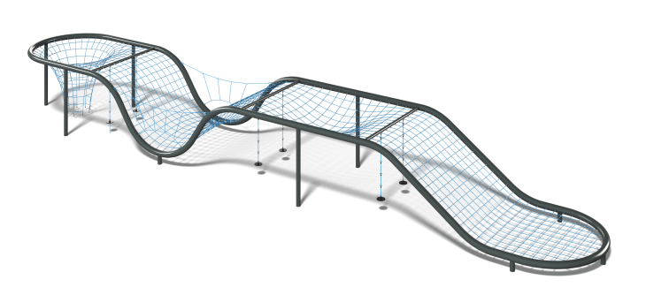

Size, mm: | 4000x24300x2910 | Weight, kg: | 2800
Material characteristics
Materials: metal, rope, pine.
Complete set: supports - 5 pcs., rope net - 1 pc., fastener kit - 1 pc.
The complex is a structure in the form of an elongated rope net on a metal frame. The net is made of polypropylene reinforced cantata with a diameter of 16 mm., connected to each other with plastic cross-shaped connectors. The ends of the rope are crimped with aluminum bushings, which are fastened with flanges to the pipe frame. The frame of the structure is made of a steel pipe with a diameter of 219 mm, protected by a polymer coating with preliminary zinc priming.
Protruding parts of threaded connections and open parts of pipes are covered with plastic plugs.
Coating of elements:
metal - powder zinc primer, powder paint.

