35.004 |  | Wall jumps
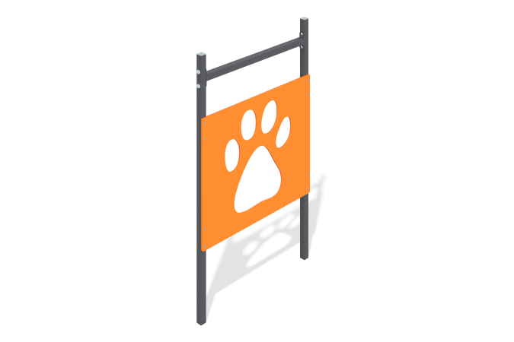

Size, mm: | 55x910x1523 | Weight, kg: | 16.709
Material characteristics
Materials: Metal, moisture-resistant birch plywood.
The Lapa barrier consists of racks made of a pipe 40 mm x 40 mm and a thickness of 2 mm, fastened together by a crossbar made of a pipe 40 mm x 40 mm and a thickness of 3 mm. A 12 mm thick plywood element with a figured cutout is installed on the racks. All open parts of the pipes are closed with plugs.
Contents: Stands - 3 pcs., shield - 1 pc., fastening set - 1 pc.

