21.047 |  | Rope Climbing Playground Saharov
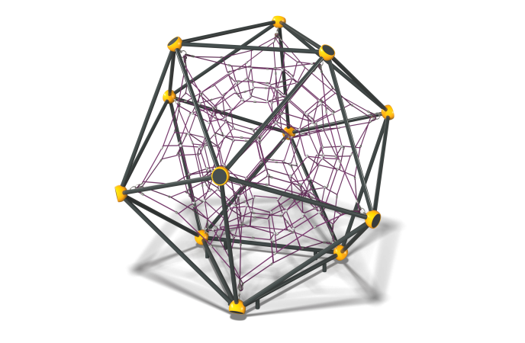

Size, mm: | 3740x4235x3735 | Weight, kg: | 442
Material characteristics
Materials: metal, rope.
Package includes: supports - 3 pcs., rope net - 1 pc., fastener kit - 1 pc.
The "Sakharov" rope structure consists of a metal frame and a rope part.
The metal frame consists of the following elements:
The ribs and supports of the structure are made of a metal pipe with a diameter of 57 mm and a wall thickness of 3 mm.
The spheres of the metal frame are made of cast aluminum alloy with a wall thickness of 8 mm, painted with powder polymer paints that are resistant to ultraviolet radiation and adverse weather conditions. They serve as connecting elements for the metal frame and the rope part, connected to each other using a bolted connection made of stainless steel;
The ribs and spheres are connected to each other using a bolted connection made of stainless steel.
The rope part consists of the following elements:
The net is made of a reinforced six-strand rope with a diameter of 16 mm, consisting of polypropylene threads and steel wire. The rope provides increased resistance of the net to ultraviolet radiation. ;
The cross-shaped connectors of the rope part are made of cast polyamide, fixed with stainless self-tapping screws;
The ends of the rope part are threaded in a loop through a metal thimble and fixed with a compression sleeve made of aluminum alloy. The sling tensioners are threaded through the thimbles.
T-shaped connections are realized with the help of compression sleeves made of aluminum alloys.
The protruding parts of the threaded connections and the open parts of the pipes are closed with plastic plugs
Coating of the elements: metal - powder zinc primer, powder paint.

