21.089 |  | Rope Climbing Playground Sakhalin
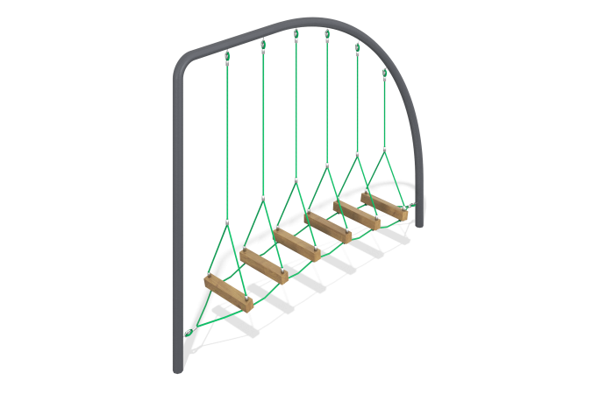

Size, mm: | 600x3000x2500 | Weight, kg: | 0
Material characteristics
Materials: metal, rope, pine.
Package includes: supports - 2 pcs., rope net - 1 pc., bars - 6 pcs., fastener kit - 1 pc.
The net is made of reinforced polypropylene 6-strand cantata with a diameter of 16 mm. The ends of the rope are crimped with aluminum bushings. The net is attached to the frame using metal clamps with an internal diameter of 133 mm, protected by a polymer coating with preliminary zinc priming. In the upper part of the complex there are gymnastic rings made of plastic, fixed to the frame with a rope and crimped connectors. The frame of the structure is made of bent steel pipe with a diameter of 133 mm, protected by a polymer coating with preliminary zinc priming.
Protruding parts of threaded connections and open parts of pipes are covered with plastic plugs. Coating of elements:
metal - zinc powder primer, powder paint.
timber - glazing primer, water-dispersion varnish.

