14.027 |  | Carousel Georgia
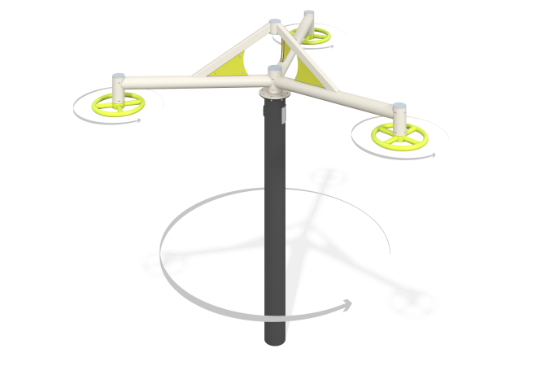

Size, mm: | 2701x2701x2378 | Weight, kg: | 108.201
Material characteristics
Main materials: HPL plastic, metal, stainless steel fasteners.
Contents: embedded parts – 1 set, support stand – 1 pc., carousel frame – 1 pc., steering wheel – 1 pc., fastening kit – 1 pc.
Design and color palette of equipment according to the sketch.
The carousel stand is made of a metal round pipe with a diameter of 159 mm and a wall thickness of 4 mm. The extension of the frame, which is attached to the support post, is made of a metal round pipe with a diameter of 89 mm and a wall thickness of 3 mm. The jib above the frame is made of a 60x40 mm profile pipe with a wall thickness of 2 mm. The gusset between the frames is made of 10 mm thick HPL plastic overlays and 5 mm metal sheet.
The steering wheel ring is made of a metal pipe with a diameter of 33.5 mm and a wall thickness of 2.8 mm. The rings and the carousel itself rotate clockwise and counterclockwise.
The complex uses stainless steel fasteners. Protruding parts of threaded connections and open parts of pipes are closed with plastic plugs.
Element coverage:
- metal - powder zinc primer, powder paint.

