35.017 |  | Whippet walk
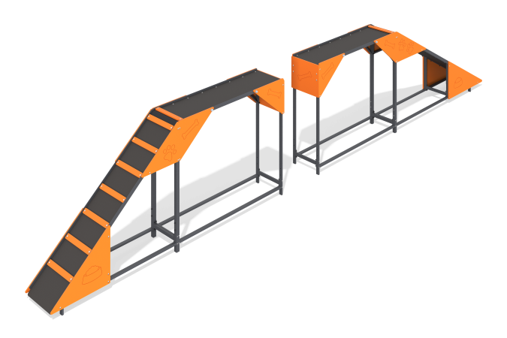

Size, mm: | 424x7110x1275 | Weight, kg: | 169.016
Material characteristics
Materials: Metal, moisture-resistant birch plywood, moisture-resistant laminated birch plywood with anti-slip coating.
The Springboard element with a slide and ladder is a four-section equipment for dogs. The structure consists of rectangular steel pipes with a cross-section of 40 mm x 20 mm x wall thickness 2 mm, a corner measuring 40 mm x 40 mm x 4 mm, which is a metal frame, a laminated plywood flooring 15 mm thick and plywood decorative themed elements 12 mm thick.
Contents: Frame - 2 pcs., Floor - 2 pcs., Plywood panels - 14 pcs., fastening kit - 1 pc.

