21.067 |  | Rope Climbing Playground Wrangel
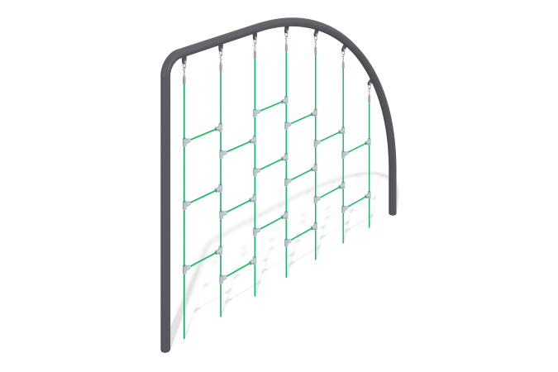

Size, mm: | 133x3133x2500 | Weight, kg: | 177
Material characteristics
Materials: metal, rope.
Complete set: supports – 2 pcs., rope net – 1 pc., fastener kit – 1 pc.
The rope structure is a metal structure in the form of an arc, inside which there is a rope part in the form of a flat climbing net.
The metal support structure consists of an L-shaped pipe with a diameter of 133 mm and a wall thickness of 4.5 mm and a radius pipe with a diameter of 133 mm and a wall thickness of 4.5 mm.
The elements of the metal structure have ears to which the rope part is attached. The ears are coated with powder paint together with the element to which they are welded.
The rope part is made of a reinforced six-strand rope with a diameter of 16 mm, consisting of polypropylene threads and steel wire. The rope provides increased resistance of the net to ultraviolet radiation. The net is fixed in the ears of the metal structure using aluminum bushings, which crimp the ends of the net ropes. The bushing has a hole for the finger and for the pin, which fixes it and protects it from falling out.
Protruding parts of threaded connections and open parts of pipes are covered with plastic plugs
Coating of elements: metal - powder zinc primer, powder paint.

