21.052 |  | Rope Climbing Playground Voltaire
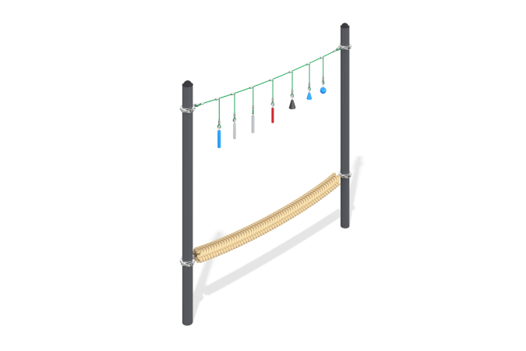

Size, mm: | 208x3190x2053 | Weight, kg: | 162
Material characteristics
Materials: metal, rope
Complete set: support posts - 2 pcs., rope crossing - 1 pc., fastener kit - 1 pc.
The Voltaire rope crossing consists of a metal frame and a rope part.
The metal frame consists of the following elements:
Two support posts are made of a pipe with a diameter of 133 mm and a wall thickness of 4.5 mm, having a support plate measuring 250 mm x 250 mm.
The rope part consists of the following elements:
The slings are made of a reinforced six-strand rope with a diameter of 16 mm, consisting of polypropylene threads and steel wire. The rope provides increased resistance of the net to ultraviolet radiation;
The ends of the sling are threaded in a loop through a metal thimble and fixed with a compression sleeve made of aluminum alloy. The thimbles are equipped with polyethylene inserts that perform a protective and decorative function; T-shaped connections of the suspension ropes are implemented using compression sleeves made of aluminum alloys. The ends of the suspension ropes are threaded in a loop through a plastic thimble made of polyamide and fixed with a compression sleeve made of aluminum alloy. Suspensions are threaded through the thimbles.
The suspension is made of composite material, a metal insert with a ring is mounted in the core.
The braided rope has a round cross-section with a diameter of 150 mm. The rope is made of polypropylene fiber, has a steel core with a diameter of 12 mm. The ends of the core are threaded in a loop through a metal thimble and fixed with a compression sleeve made of aluminum alloy. The ends are wrapped with a soft rope, protecting the free ends of the braided rope from fuzzing, and heat shrinkage resistant to ultraviolet radiation is installed on top. The rope is characterized by increased strength, the breaking load is 300 tons, has excellent resistance to abrasion, and good resistance to ultraviolet radiation.
The clamps are made of two halves connected to each other using bolted connections, made of stainless steel. They are designed for installation on metal pipes with a diameter of 133 mm. Internal plastic plug with ribs and a thick spherical cap for round pipes with an external cross-section diameter of 133 mm and a pipe wall thickness of 2.0-6.0 mm.
The protruding parts of the threaded connections and open parts of the pipes are closed with plastic plugs
Coating of elements: metal - powder zinc primer, powder paint.

