35.010 |  | Dog hill climb
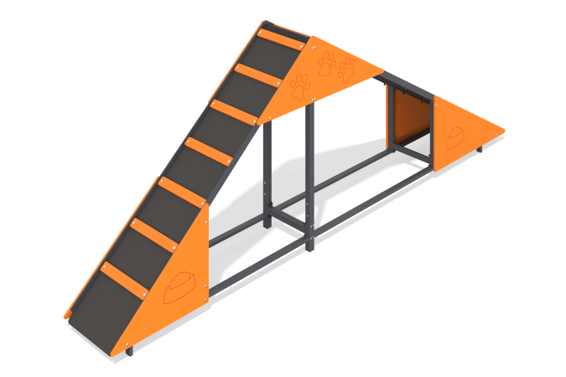

Size, mm: | 424x3510x1273 | Weight, kg: | 86.58
Material characteristics
Materials: Metal, moisture-resistant birch plywood, moisture-resistant laminated birch plywood with anti-slip coating.
The slide-ladder element is a two-section piece of equipment for dogs. The structure consists of rectangular steel pipes 40 mm x 20 mm x 2 mm, which constitute a metal frame, a 15 mm thick laminated plywood flooring and 12 mm thick plywood decorative themed elements. The product is painted with polymer paints.
Contents: Frame - 1 piece, Steps - 14 pieces, Plywood panels - 6 pieces, fastening kit - 1 piece.

