34.155 |  | Illuminated hemisphere
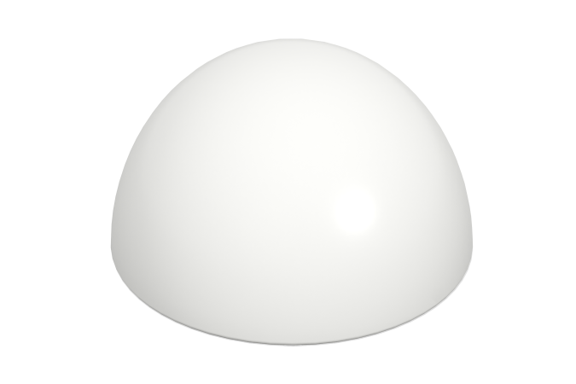

Size, mm: | 400x400x200 | Weight, kg: | 1
Material characteristics
Materials: plastic
Package: Hemisphere with backlight - 1 pc.
The product is designed for aesthetic improvement of parks and urban public spaces. Color white translucent light-transmitting. The product is made of 3D plastic: linear low-density polyethylene for rotational molding (rotational molding), which does not fade and does not deteriorate under the influence of sunlight. Surface type - shagreen. Operating temperature in the range from -60 to +60 degrees Celsius.

