19.073 |  | Sandpit Treasure
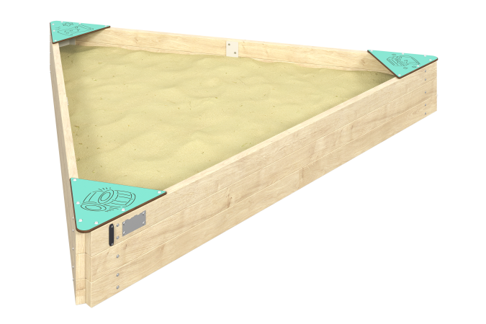

Size, mm: | 2240x2575x310 | Weight, kg: | 49.491
Material characteristics
Main materials: planed softwood board, HPL plastic, metal, stainless fasteners.
Contents: embedded parts - 1 set, sandbox frame - 1 pc., seat - 3 pcs., fastening kit - 1 pc.
Design and color palette of equipment according to the sketch.
The frame of the sandbox is a planed softwood board with a section of 100x40 mm. The seat is made of double-sided HPL plastic with UV protection, 10 mm thick. Drawings are applied to the seat using engraving and UV printing.
The complex uses stainless steel fasteners. Protruding parts of threaded connections and open parts of pipes are closed with plastic plugs.
Element coverage:
- metal - powder zinc primer, powder paint.

