34.157 |  | Illuminated cube
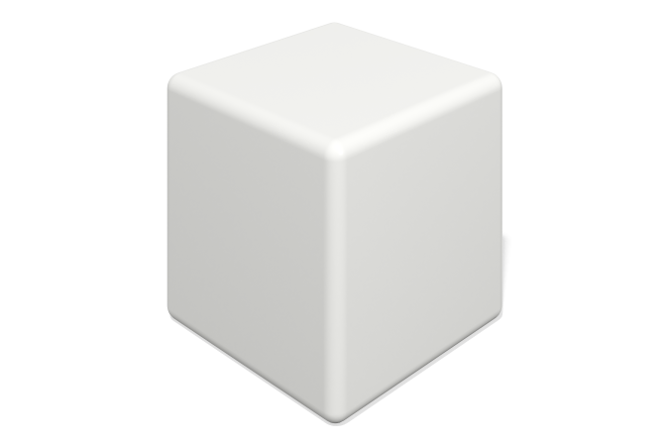

Size, mm: | 400x400x400 | Weight, kg: | 5
Material characteristics
Materials: plastic
Package: Illuminated cube – 1 pc.
The product is designed for aesthetic improvement of parks and urban public spaces. Color: white, translucent, light-transmitting. The product is made of 3D plastic: linear low-density polyethylene for rotational molding (rotational molding), which does not fade or deteriorate under the influence of sunlight. Surface type: shagreen. Operating temperature range from -60 to +60 degrees Celsius.

