23.039 |  | Play system Portal
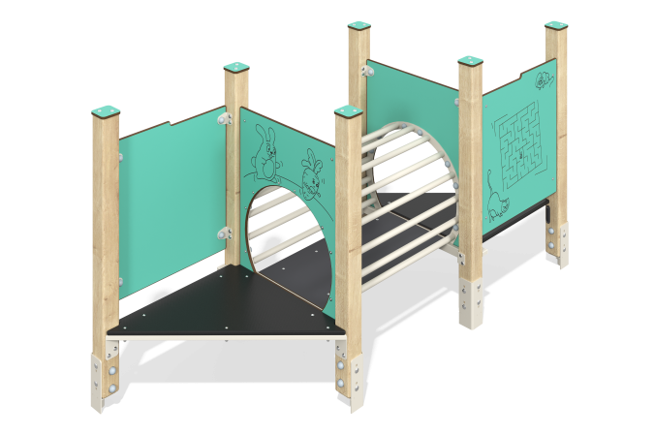

Size, mm: | 760x2226x1167 | Weight, kg: | 91.615
Material characteristics
Main materials: softwood timber, laminated plywood with anti-slip coating, HPL plastic, metal, stainless fasteners.
Contents: embedded parts - 1 set, support posts - 6 pcs., bridge-transition - 1 pc., floors - 1 set, decorative panels - 1 set, fastening kit - 1 pc.
Design and color palette of equipment according to the sketch.
The game module consists of support posts made of laminated coniferous timber with a cross-section of 80x80 mm. The profile is square, the corner radius is R10. The transition bridge is presented in the form of a metal bridge made of round pipes with a diameter of 26.8 mm with a wall thickness of 2.8 mm and a floor made of laminated plywood 18 mm thick with an anti-slip coating. The frame of the gaming module is made of a 40x20 mm profile pipe with a wall thickness of 2 mm.
Decorative panels are made of HPL plastic 10 mm thick. Drawings are applied to panels and game elements using engraving and UV printing.
The complex uses stainless steel fasteners. Protruding parts of threaded connections and open parts of pipes are closed with plastic plugs.
Element coverage:
- metal - powder zinc primer, powder paint;
- timber - glazing primer, water-dispersion varnish.

