34.161 |  | Figure Bear with lighting
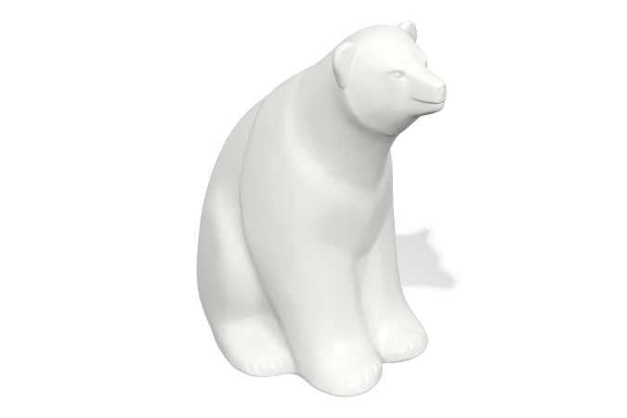

Size, mm: | 700x1050x1100 | Weight, kg: | 8
Material characteristics
Materials: plastic
Package: Illuminated figure in the shape of a bear - 1 pc.
The product is intended for the aesthetic improvement of parks and urban public spaces. The color is white, translucent, light-transmitting. The product is made of 3D plastic: linear low-density polyethylene for rotational molding (rotational molding), which does not fade and does not deteriorate under the influence of sunlight. Surface type - shagreen. Operating temperature range from -60 to +60 degrees Celsius.

