34.162 |  | Figure Hermelin with lighting
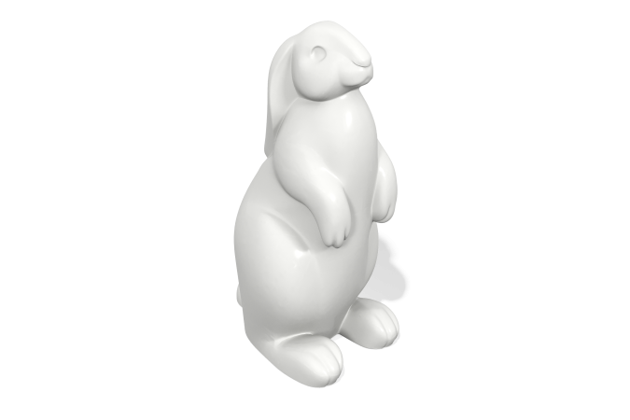

Size, mm: | 520x630x1080 | Weight, kg: | 6
Material characteristics
Materials: plastic
Package: Illuminated figure in the shape of a hare - 1 pc.
The product is intended for the aesthetic improvement of parks and urban public spaces. Color white translucent light-transmitting. The product is made of 3D plastic: linear low-density polyethylene for rotational molding (rotational molding), which does not fade and does not deteriorate under the influence of sunlight. Surface type - shagreen. The operating temperature ranges from -60 to +60 degrees Celsius. The product does not require additional care and maintenance. Resistant to chipping. The material from which the product is made does not absorb reagents, is resistant to chemical influences and is suitable for recycling (recyclable).

