35.008 |  | Scottie seesaw
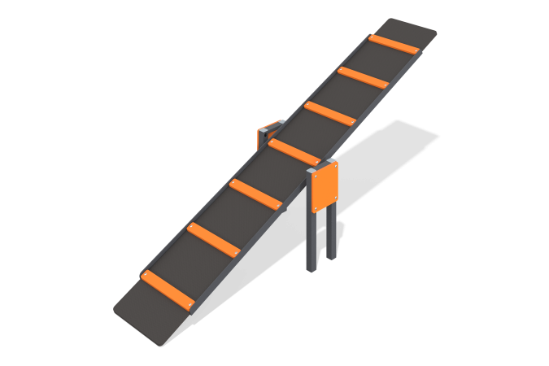

Size, mm: | 590x2318x870 | Weight, kg: | 37.663
Material characteristics
Materials: Metal, moisture-resistant birch plywood, moisture-resistant laminated birch plywood with anti-slip coating.
The dog balancer is a 15mm laminated plywood element with steps mounted on a 40mm x 40mm x 2mm angle frame. The frame is attached through a movable hinge to racks consisting of a profile pipe 40 mm x 20 mm x 2 mm with a decorative element made of 12 mm plywood installed on them. The metal is powder coated. All open parts of the pipes are closed with 40 mm x 40 mm plugs; the fasteners have no traumatic protrusions or edges.
Contents: Stands - 2 pcs., frame - 1 pc., plywood elements - 1 set, fastening kit - 1 pc.

