34.163 |  | Figure Doe with lighting
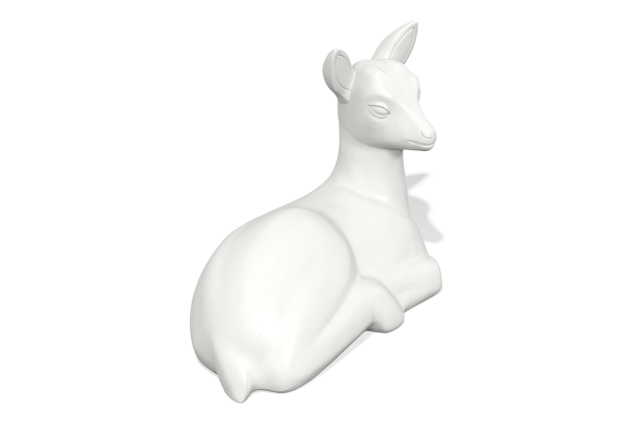

Size, mm: | 480x940x700 | Weight, kg: | 6
Material characteristics
Materials: plastic
Package: Backlit figure in the shape of a doe - 1 pc.
The product is intended for the aesthetic improvement of parks and urban public spaces. The color is white, translucent, translucent. The product is made of 3D plastic: linear low-density polyethylene for rotational molding (rotational molding), which does not fade and does not deteriorate under the influence of sunlight. Surface type - shagreen. Operating temperature range from -60 to +60 degrees Celsius.

