34.097 |  | Altair bench with lighting
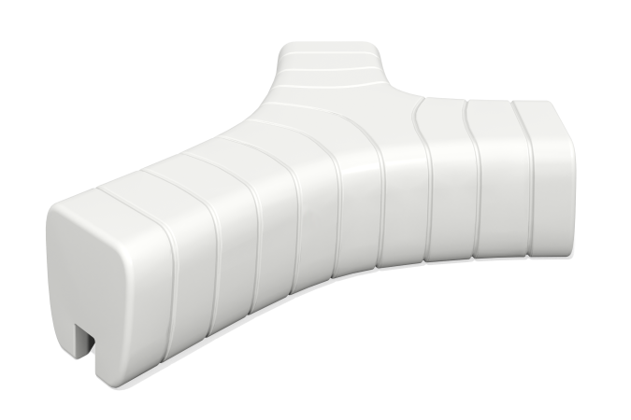

Size, mm: | 1440x1750x420 | Weight, kg: | 31
Material characteristics
Materials: plastic Complete set: bench - 1 pc.
Bench with a maximum load of 250 kg and the ability to attach to the floor.
Bench with built-in lighting has a completely sealed housing with dust and moisture protection index IP68, that is, it can withstand immersion in water to a depth of 6 m under pressure, after which it remains in working condition.

