ML4036 |  | Play System
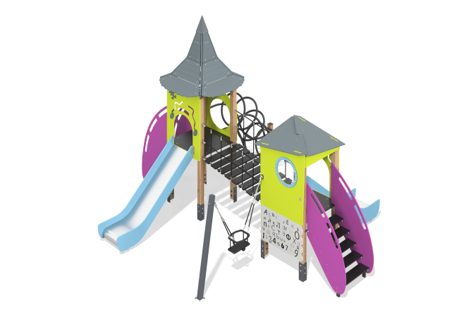

Size, mm: | 4865x5415x3755 | Weight, kg: | 558.8
Material characteristics
Main materials: pine softwood timber, laminated plywood with anti-slip coating, moisture-resistant birch plywood, HPL plastic, metal, stainless steel, reinforced polypropylene rope, stainless fasteners.
Package contents: Embedded parts - 20 pcs., support posts - 10 pcs., swing support post – 1 pc., floors - 2 pcs., enclosing panels and decorative panels - 7 pcs., roof - 2 sets, straight slides - 2 pcs., game element "caterpillar" - 1 pc., suspension bridge - 1 ladder with railings - 2 pcs., closed swing seat - 1 pc., seat suspension - 2 sets, mounting kit - 1 pc.
The equipment consists of 2 cabins. The support posts are made of glued softwood lumber with a cross section of 100x100 mm, the radius of rounding the corners is 10 mm.
The floors of the houses, the steps of the stairs and the suspension bridge are made of laminated plywood 18 mm thick with anti-slip coating. Decorative panels, roof panels are made of moisture-resistant birch plywood 15 mm thick, roof posts are made of plywood 24 mm. A drawing is applied to the panel using UV printing. The decorative insert in the form of a window is made of monolithic polycarbonate 5 mm thick. The caps on the support posts are made of 10 mm thick HPL.
The game element "caterpillar" is made of a round tube with a diameter of 42.3 mm and a wall thickness of 2.8 mm. The swing support stand is made of 80x80 mm profile tube. The ladder supports are made of 60x40 mm profile tube with a wall thickness of 2 mm.
The passage between the houses is represented as a rope bridge made of six-row reinforced polypropylene rope d = 16 mm with steps made of laminated plywood 18 mm thick with anti-slip coating. Rope and stainless steel chains are used as swing suspensions.
The game complex includes 2 straight slides. Straight slides h = 0.95 m and h= 1.2 m consist of a ramp and sides, in turn made of stainless steel sheet 1.5 mm thick and moisture-resistant birch plywood 18 mm thick, respectively. The slide supports are made of 5 mm thick metal sheet.
The complex uses stainless steel fasteners and galvanized fasteners. The protruding parts of the threaded connections and the exposed parts of the pipes are covered with plastic plugs.
Coating of the elements:
- metal - powder zinc grunt, powder paint;
- timber - lessening primer, water-dispersion varnish;
-plywood - acrylic primer, acrylic enamel, water-dispersion varnish.

