35.006 |  | Agility weave poles
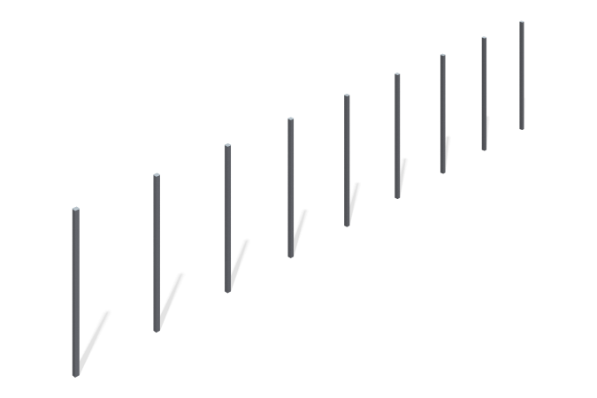

Size, mm: | 40x6080x1250 | Weight, kg: | 37.422
Material characteristics
Materials: Metal. The snake for dogs consists of 9 racks made of pipe 40 x 40 mm with a wall thickness of 2 mm.
Painting with polymer paints for metal. All open parts of the pipes are closed with 40 mm x 40 mm plugs.
Contents: Stands - 9 pieces.

