28.033 |  | Youth Fitness Equipment Gymnastic
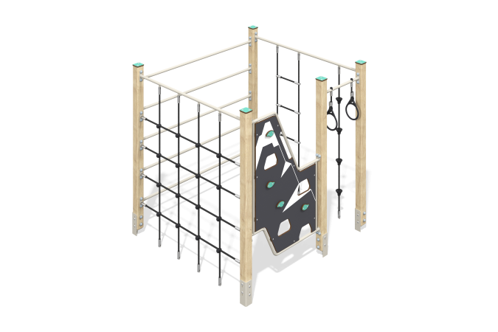

Size, mm: | 1590x1690x1660 | Weight, kg: | 98.12
Material characteristics
Materials: Coniferous wood, metal, HPL plastic, reinforced polypropylene rope.
Contents: support posts – 5 pcs; panel with ledges – 1 set; horizontal metal ladder – 1 piece; ropes with plastic ledges - 4 pcs; rope ladder - 1 piece; rope mesh - 1 piece, fastening kit - 1 set.
Design and color palette of equipment according to the sketch.
The complex consists of 5 support pillars with a cross section of 80 mm x 80 mm, made from laminated veneer lumber, consisting of three layers of dry softwood boards. All posts are polished, the edges are rounded (rounding radius 20 mm). The treated surfaces are varnished. The upper ends of the pillars are closed with caps made of HPL plastic 10 mm thick.
The metal elements of the rungs of the complex and the stairs are made of a round pipe with a diameter of 26.8 mm and a wall thickness of 2.8 mm.
The first section contains a 14mm thick HPL panel with climbing hooks. The frame is made of a round pipe with a diameter of 26.8 mm and a wall thickness of 2.8 mm. The hooks on the panels are made of HPL plastic 10 mm thick. The second section contains a mesh made of reinforced polypropylene rope with a diameter of 16 mm. In the third section there is a ladder made of 5 metal round pipes with a diameter of 26.8 mm and a wall thickness of 2.8 mm. The fourth section contains a 16mm diameter rope with 16mm diameter plastic climbing ledges and a rope ladder. In the fifth section, two gymnastic rings made of plastic are installed on the crossbar.
Caps made of HPL plastic with UV protection 10 mm thick are installed on the upper part of the support posts.
The complex uses stainless steel fasteners. Protruding parts of threaded connections and open parts of pipes are closed with plastic plugs.
Element coverage:
- metal - powder zinc primer, powder paint;
- timber - glazing primer, water-dispersion varnish.

