35.003 |  | Maze for dogs
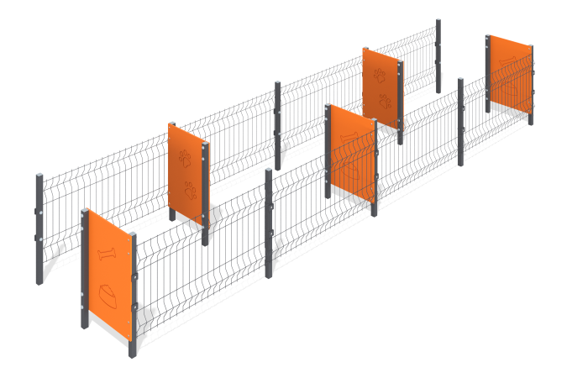

Size, mm: | 1300x5100x823 | Weight, kg: | 96.621
Material characteristics
Materials: Metal, moisture-resistant birch plywood.
The labyrinth uses metal posts 40 mm x 40 mm x 3 mm thick for fastening, 5 moisture-resistant plywood 12 mm thick to create obstacles, and galvanized fencing. Painting with polymer paints. The racks are attached on opposite sides of the plywood. All open parts of the pipes are closed with 40 mm x 40 mm plugs, fasteners - with plugs.
Contents: Racks - 15 pcs, plywood elements - 5 pcs, fencing - 2 sets, fastening kit - 1 pc.

