28.032 |  | Youth Fitness Equipment Hero
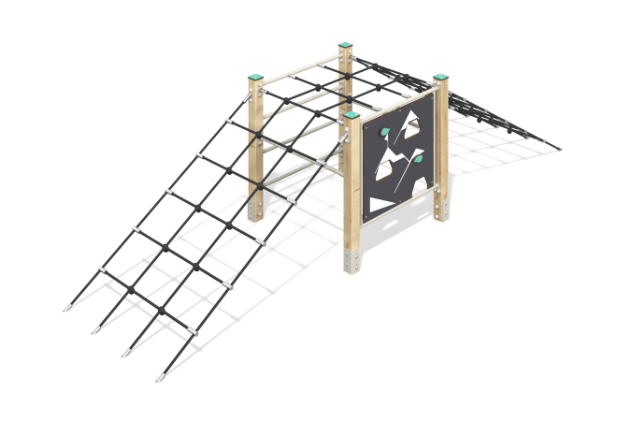

Size, mm: | 1010x4030x1060 | Weight, kg: | 66.13
Material characteristics
Materials: Coniferous wood, metal, HPL plastic, reinforced polypropylene rope d=16 mm.
The complex consists of 4 support pillars with a cross-section of 80 mm x 80 mm, made from laminated veneer lumber, consisting of three layers of dry softwood boards. All posts are polished, the edges are rounded (rounding radius 20 mm). The treated surfaces are varnished. The upper ends of the pillars are closed with caps made of HPL plastic 10 mm thick.
The metal elements of the rungs of the complex and the staircase are made of a round pipe with a diameter of 26.8 mm and a wall thickness of 2.8 mm.
Between the posts on one side there is a 14 mm thick HPL panel with climbing hooks. The frame is made of a round pipe with a diameter of 26.8 mm and a wall thickness of 2.8 mm. The hooks on the panels are made of HPL plastic 10 mm thick.
Opposite the panel, between the pillars, there is a metal staircase, which is made of a round pipe with a diameter of 26.8 mm and a wall thickness of 2.8 mm.
In the middle of the complex there is a structure made of reinforced polypropylene rope with a diameter of 16 mm, consisting of two inclined and one horizontal mesh.
All existing metal parts are painted with polyester powder paint.
The complex uses stainless steel fasteners.
Contents: support posts – 4 pcs; panel with ledges – 1 set; metal ladder – 1 piece; rope mesh - 1 set; fastening kit – 1 set.

