35.001 |  | Dog walk ramp with ladder
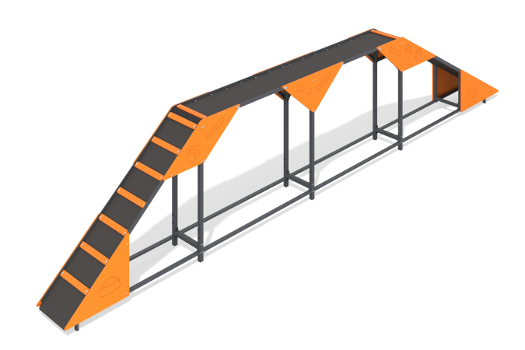

Size, mm: | 424x6510x1275 | Weight, kg: | 166.64
Material characteristics
Materials: Metal, moisture-resistant birch plywood, moisture-resistant laminated birch plywood with anti-slip coating.
The Boom element with slide and ladder is a four-section equipment for dogs. The structure consists of a metal frame made of a profile pipe measuring 40 mm x 40 mm x 4 mm, a flooring made of laminated plywood 15 mm thick and plywood decorative thematic elements 12 mm thick. The product is painted with polymer paints.
Contents: Frame - 1 piece, Steps - 14 pieces, Plywood panels - 10 pieces, floor - 1 piece, fastening kit - 1 piece.

