38.001 |  | Canopy 5.5x6 over the fitness equipment
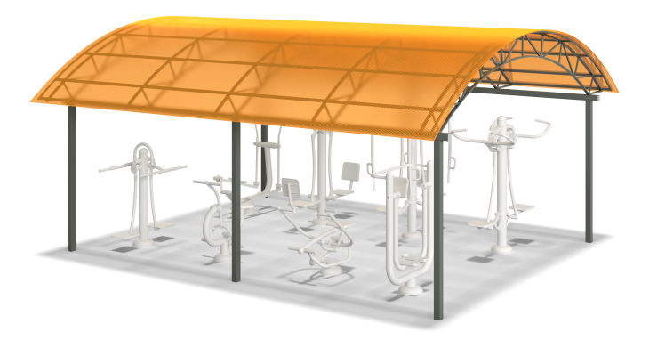

Size, mm: | 5530x6300x3100 | Weight, kg: | 298.378
Material characteristics
Materials: cellular polycarbonate, metal, powder paint.
Bolted frame made of profile pipe 80x80 mm with a wall thickness of 3 mm, 40x20 mm with a wall thickness of 2 mm, 40x40 with a wall thickness of 2 mm and 20x20 mm with a wall thickness of 1.5 mm. All frame metal elements are painted with a protective anti-corrosion decorative coating.
The roof is made of 10 mm cellular polycarbonate.
The open parts of the profile pipes are closed with plastic plugs;
All existing metal parts are painted with polyester powder paint.
The fastening kit is galvanized.
Contents: Frame - 1 pc. Canopy – 1 pc. Fastening kit – 1 pc.

