43.041 |  | Sphere with rope
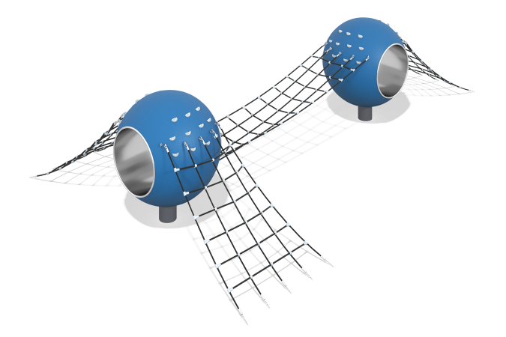

Size, mm: | 4500x7500x1700 | Weight, kg: | 1000
Material characteristics
Materials: metal, rope, plastic, rubber
Complete set: sphere - 2 pcs., rope net - 1 pc.,
The play element with a tunnel and a spatial rope net is made of durable and wear-resistant materials - AISI 304 stainless steel, reinforced rope, polyamide and EPDM crumbs. The structure is mounted on a fiberglass frame reinforced with a 25x25x2 mm metal pipe, without loose fillers. The coating is made of EPDM crumbs on an aliphatic binder (thickness 8 mm) with a shock-absorbing layer (20 mm), ensuring safe use. The tunnel with a diameter of 900 mm is made of stainless steel (thickness 1.5 mm, surface 2B), reinforced at the edges with a Ø32 mm pipe. The rope network made of six-strand reinforced rope Ø16 mm with polyamide connectors is secured with aluminum bushings (AMts 3003), compressed with a 150-ton press, and is fixed to the platform with a stainless chain, concreted to a depth according to GOST. All fasteners are stainless, which prevents corrosion and guarantees the durability and aesthetics of the product. Installation is carried out by gluing or anchoring.

