34.468 |  | Support bench
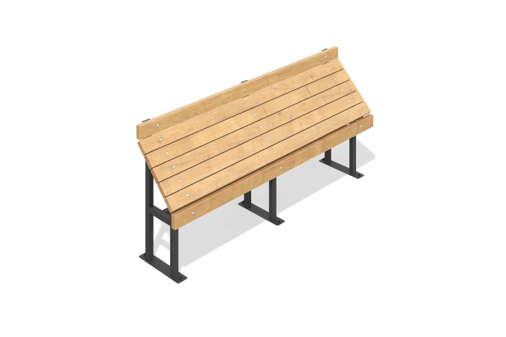

Size, mm: | 440x2000x900 | Weight, kg: | 0
Material characteristics
Materials: coniferous wood - pine, metal.
Contents: frame - 1 pc., support - 1 pc., backrest - 1 set, fastening kit - 1 pc.
The frame of the bench is made of metal profile pipes. The uprights and crossbars are made of profile pipe 40x40 mm with a wall thickness of 2 mm. Profile bending, the profile itself is made of a 60x30 mm profile pipe with a wall thickness of 2 mm. The bench support (seat) is made of planed pine boards 90x35 mm.
The equipment uses stainless steel fasteners. The protruding parts of threaded connections and open parts of pipes are closed with plastic plugs.
Element coverage:
- metal - powder zinc primer, powder paint;
- timber - glaze primer, water-dispersion varnish.

