34.497 |  | Bench Snail (HPL)
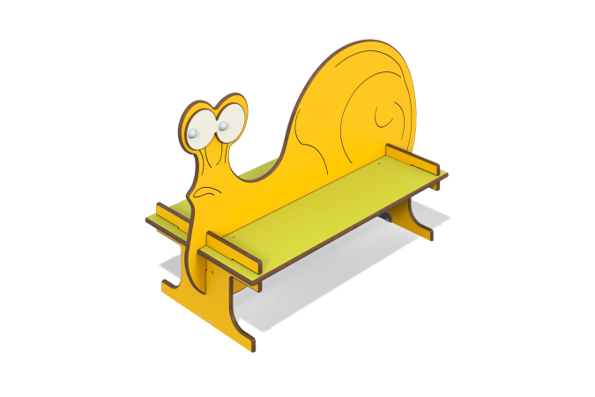

Size, mm: | 517x1149x710 | Weight, kg: | 16.55
Material characteristics
Materials: HPL plastic, metal, acrylic paint, powder paint.
The bench is installed on 4 embedded elements made of a 40x20 mm steel profile pipe with a wall thickness of 2 mm and a 40x2 mm steel strip
In case of fastening with anchor bolts, the bench is installed on 40x40x30x3 mm steel corners.
The bench parts are made of 14 mm thick HPL.
All available metal parts are painted with polyester powder paint. All threaded connections are covered with decorative plugs.
Complete set:
Element “Snail” - 1 pc.
Element “Leg” - 2 pcs.
Element “Eyes” - 2 pcs.
Seat - 2 pcs.
Embedded elements - 4 pcs.
Set of fasteners and plugs - 1 pc.
Installation: The product is installed on embedded elements with concreting or using anchor bolts through corners.

