39.149 |  | Dumstep enclosure with doors (3 containers)
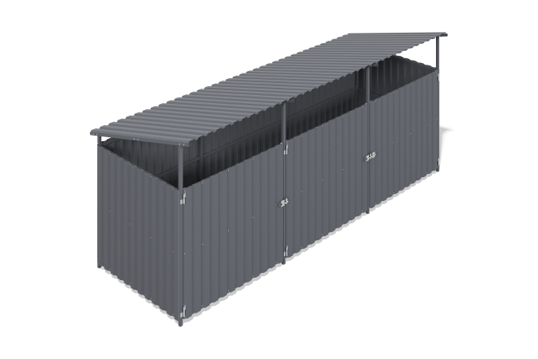

Size, mm: | 1960x5000x2200 | Weight, kg: | 182.34
Material characteristics
Materials: metal.
Package contents:
Side sections - 2 pcs., intermediate sections - 2 pcs., strapping crossbars - 18 pcs., welded doors - 3 pcs. embedded parts - 8 pcs., profiled sheet length 1500 mm - 13 pcs., profiled sheet length 2000 mm - 6 pcs.
A 3-section container platform with doors is designed to accommodate containers and protect them from rain and other weather events. The frame is made of welded walls, lintels and doors made of 40x40 mm and 40x20 mm profile pipes with a wall thickness of 2 mm, flanges and plastic elements. All metal parts are shotblasted, stripped, degreased and painted with powder paint. The cladding is made of galvanized C20 corrugated sheet with polymer coating, secured with roofing screws with press washers.

