23.001 |  | Play Panel Gas station
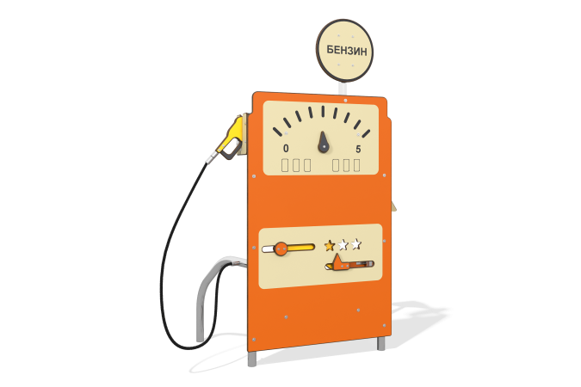

Size, mm: | 660x1269x1757 | Weight, kg: | 42.749
Material characteristics
Main materials: HPL plastic, metal, stainless steel, reinforced polypropylene rope, stainless fasteners.
Contents: embedded parts - 1 set, support posts - 2 pcs., gun with rope - 1 pc., "Gas station" panel - 1 pc., "Fuel" lining - 1 pc., "flammable" lining - 1 pc., fastening set - 1 pc.
Design and color palette of equipment according to the sketch.
The game module consists of a gas station with a refueling nozzle. The support posts and cross members are made of stainless steel pipe with a diameter of 42.4 mm and a wall thickness of 2 mm.
Panel "Gas Station" and its components: Sign "Gasoline", Sign "Flammable", decorative elements and canister are made of HPL plastic 14 mm thick. The refueling nozzle consists of a reinforced polypropylene rope, a side lining on the nozzle made of 10 mm thick HPL plastic and a nozzle made of 14 mm thick HPL plastic.
Drawings are applied to the panels using engraving and UV printing.
The Gas Station gaming panel is designed for thematic play and motor development. Purpose of the game “Gas Station”: The gun must be carefully removed from the landing stand at the pump, turn the sliders, selecting “gasoline”.

