30.036 |  | Labyrinth Hexagon
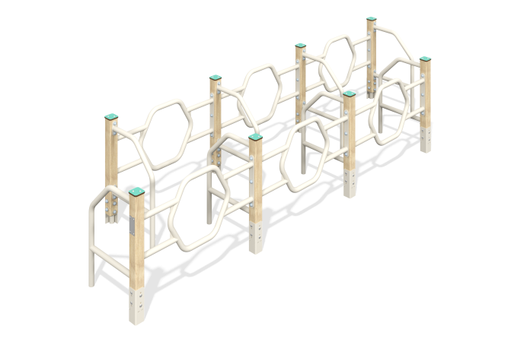

Size, mm: | 1200x4200x900 | Weight, kg: | 141.794
Material characteristics
Main materials: softwood timber, HPL plastic, metal, stainless steel fasteners.
Contents: embedded parts - 1 set, support posts - 8 pcs., hexagon fencing - 6 pcs., side fencing - 8 pcs., fastening kit - 1 pc.
Design and color palette of equipment according to the sketch.
The labyrinth consists of 6 sections through which you must pass. The support posts are made of laminated coniferous timber with a cross-section of 80x80 mm. The profile is square, the corner radius is R10.
The metal side fences between the support pillars are hexagon-shaped structures made using metal round pipes with a diameter of 42.3 mm and a wall thickness of 2.8 mm. The side fence is also made of metal round pipes with a diameter of 42.3 mm and a wall thickness of 2.8 mm.
Caps made of HPL plastic with UV protection 10 mm thick are installed on the upper part of the support posts.
The complex uses stainless steel fasteners. Protruding parts of threaded connections and open parts of pipes are closed with plastic plugs.
Element coverage:
- metal - powder zinc primer, powder paint;
- timber - glazing primer, water-dispersion varnish.

