34.478 |  | Park Bench
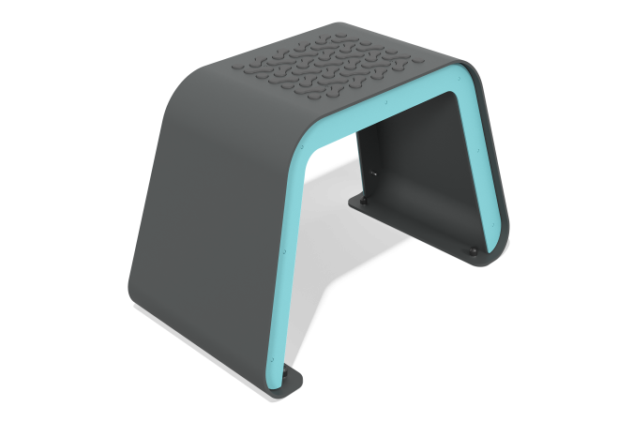

Size, mm: | 400x728x453 | Weight, kg: | 0
Material characteristics
Materials: metal, HDPE plastic.
Contents: bench - 1 pc., fastening kit - 1 pc.
The bench frame is made of sheet metal 4 mm thick. The welded ribs are made of a 6 mm thick sheet of metal, the lining on the sides of the bench is made of a 3 mm thick sheet of metal. The substrate is made of HDPE plastic with a thickness of 15 mm. The radius of rounding the edges of the protrusion is R3.
The equipment uses stainless steel fasteners. The protruding parts of threaded connections and open parts of pipes are closed with plastic plugs.
Element coverage:
- metal - powder zinc primer, powder paint.

