43.006 |  | Climbing Net
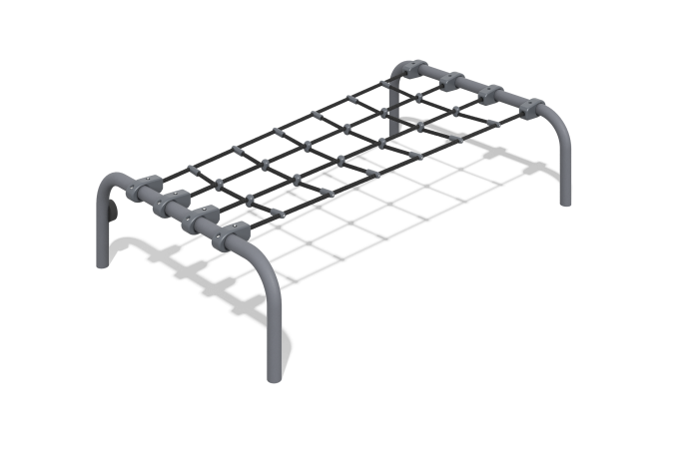

Size, mm: | 1200x2000x450 | Weight, kg: | 44.1015
Material characteristics
Primary Materials:
Metal (Steel tubing)
Reinforced polypropylene rope
Hose clamps
Stainless steel fasteners
Components:
Metal posts - 2 pcs.
Rope net - 1 pcs.
Hose clamps - 8 pcs.
Fastener kit - 1 set
Design Features:
The climbing net structure consists of two metal posts installed at a height of 450 mm above the finished surface level. The posts are made of round steel profile tubing with a diameter of 57 mm and a wall thickness of 3 mm.
A rope net, made of 6-strand reinforced polypropylene rope with a diameter of 16 mm, is tensioned between the posts. The net is secured to the posts using 8 heavy-duty plastic hose clamps.
Coating:
Metal posts: Powder coating

