34.479 |  | Park Bench
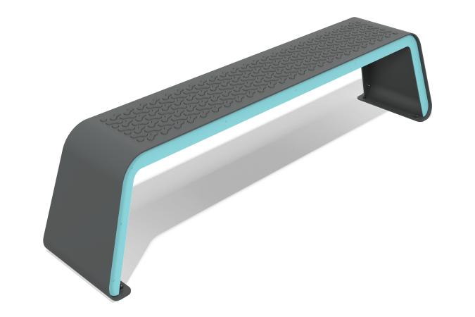

Size, mm: | 400x2000x453 | Weight, kg: | 0
Material characteristics
Materials: metal, HDPE.
The bench is a welded metal frame with a seat mounted on it.
The metal frame consists of a metal sheet with a thickness of 6 mm and 4 mm. An overlay is fixed on the metal frame, which is made of a metal sheet 3 mm thick.
The seat is presented in the form of a ribbed backing made of HDPE plastic with a thickness of 15 mm.
Package contents: park bench assembly – 1 piece, a set of fasteners - 1 piece.

